SL No. | Programs | Title | Date
01 | Workshop | Environmental Impact Assessment Regulations and Practices in Bangladesh | 09/03/2018
02 | Workshop | Workshop on Adaptation of WATSAN and Hygiene Issues | 10/01/2019
03 | Training | Training on Climate Change: Effects and Adaptation | 25/02/2020
04 | Webinar | Sanitation and Sanitariness: The role of Barriers | 15/10/2020
05 | Webinar | Occupational Health Hazard & Safety of Waste Workers in Pandemic Situation | 01/06/2021
06 | Webinar | Environmental Restoration towards Circular Economy | 14/06/2021

01.
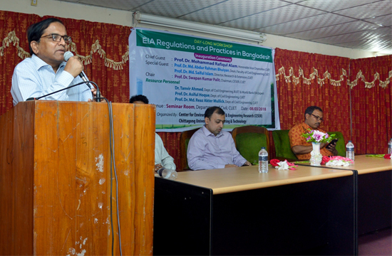

02.
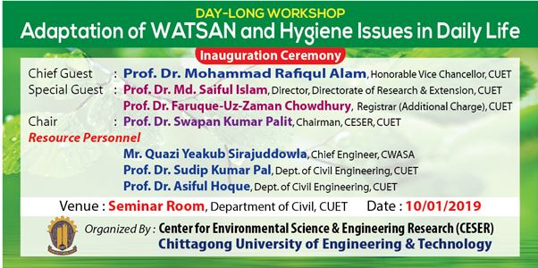

03.
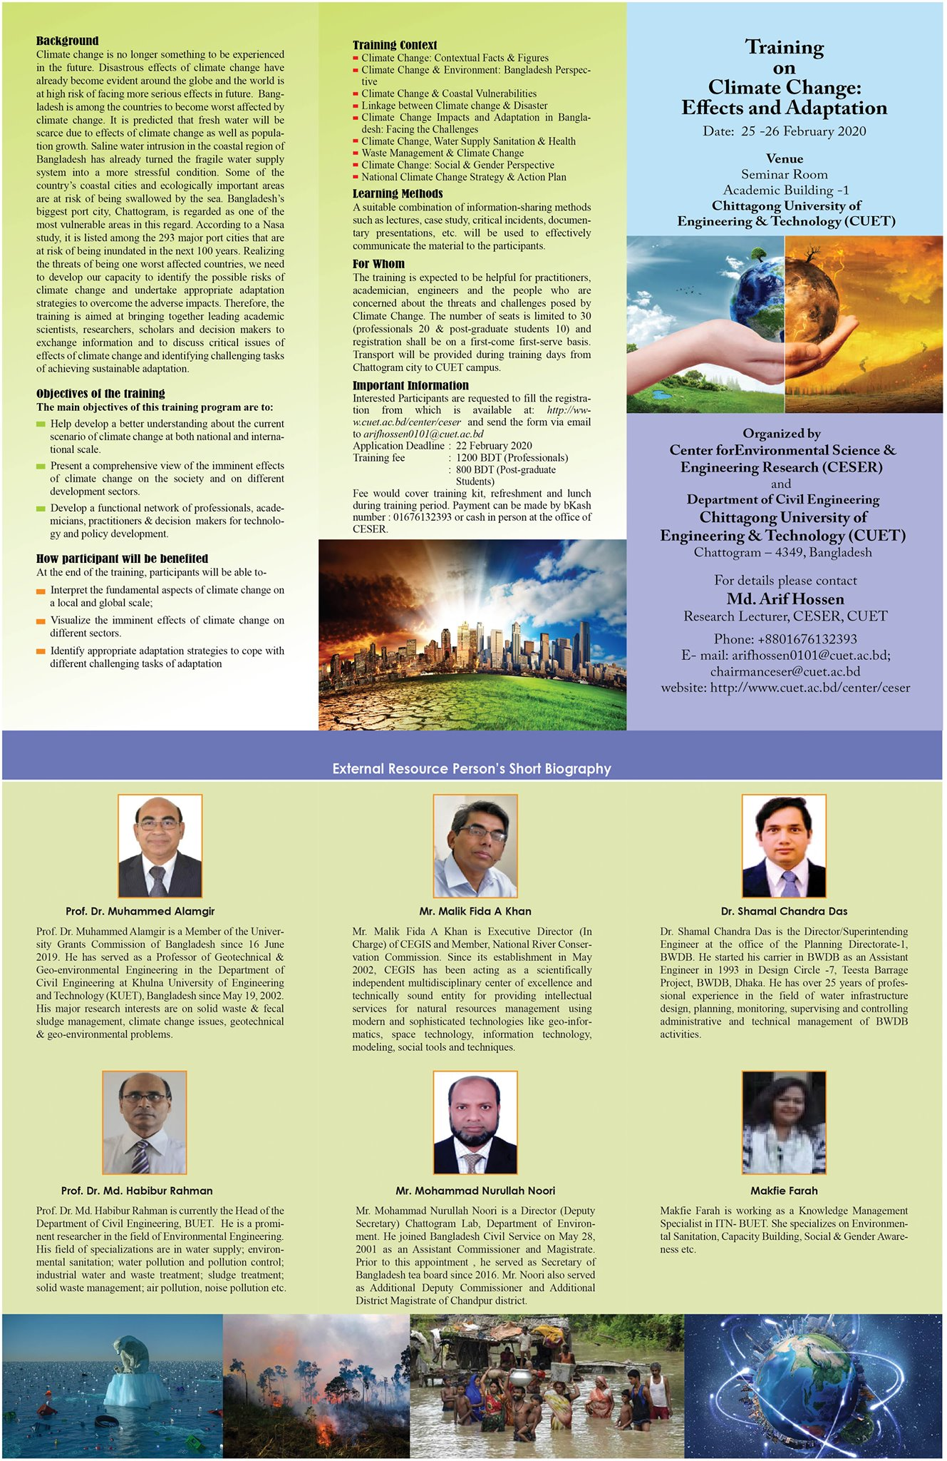

04.
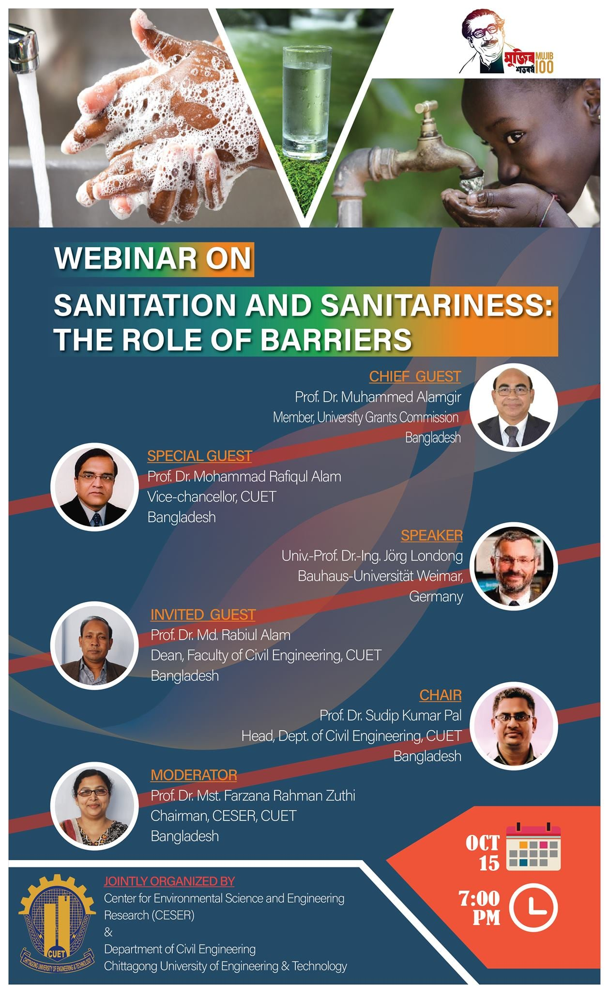
05.
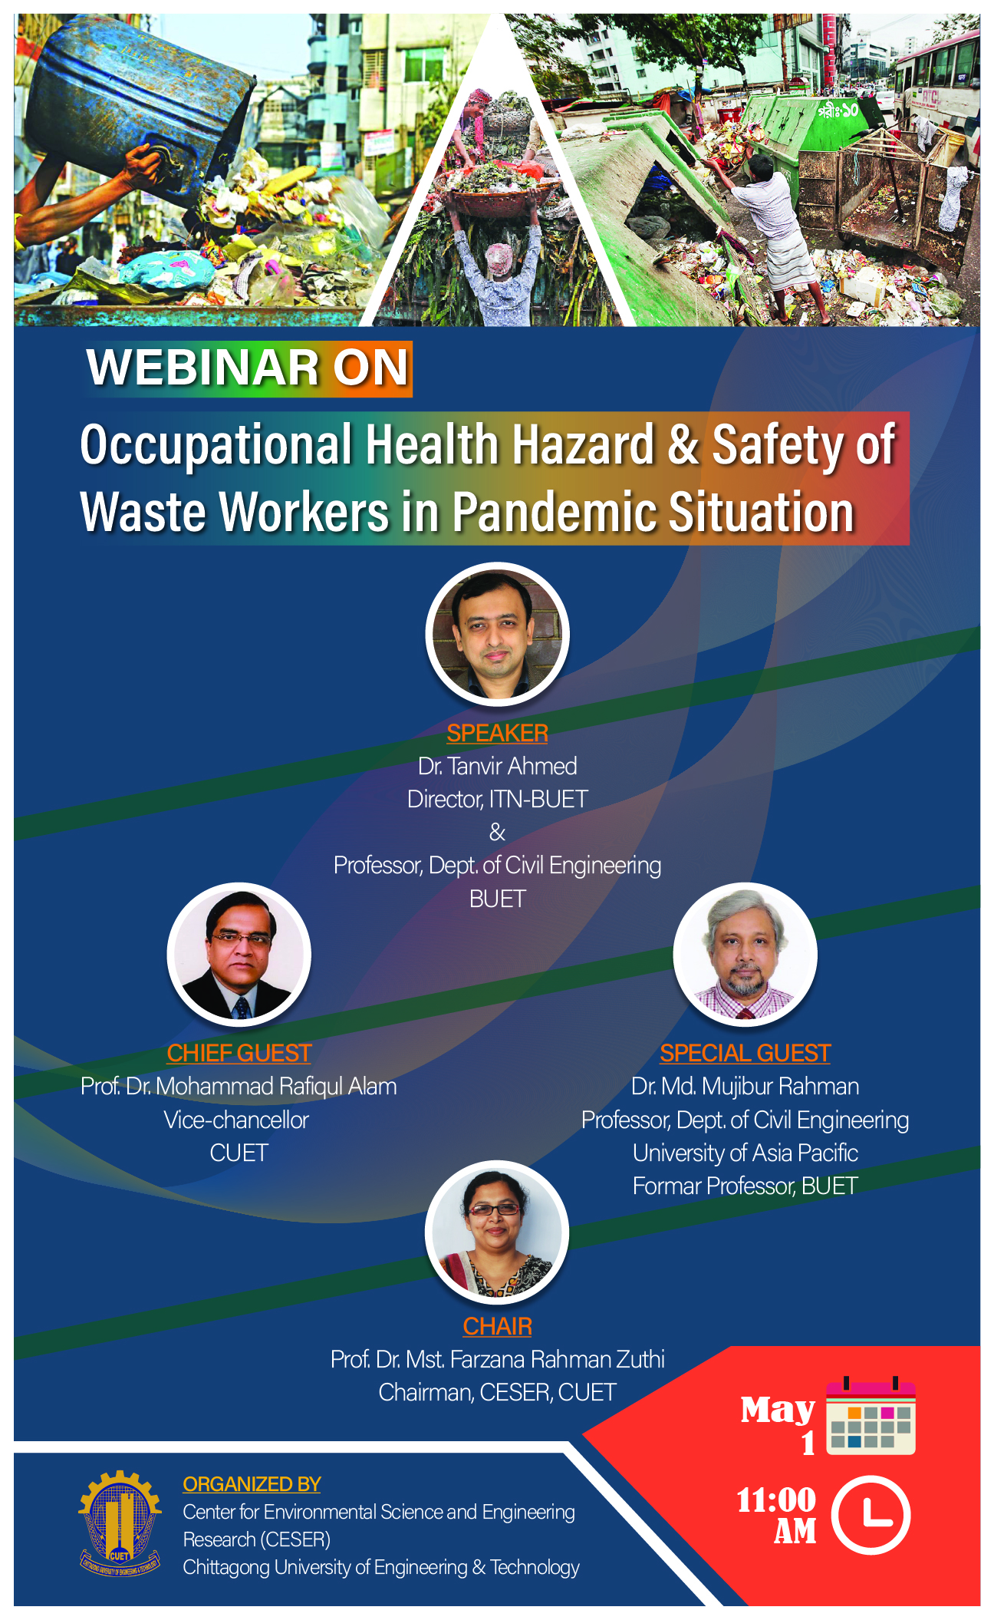
06.
